Necessary documents on behalf of the republic of seychelles – Passenger
Since September 15, 2020 every traveler to the Seychelles must have an approved Travel Authorization (TA) to be allowed to travel to the Seychelles. This includes children, infants as well as Seychellois and all foreigners.
Check-in and boarding airline staff need to check the TA and that it matches the traveler passport.
The Travel Authorization may be presented by the traveler:
- As a printed document – example is below
- As an email attachment, downloaded to the mobile device, as a PDF
  - The email sender is no-reply@seychelles.govtas.com
- Saved as a pass in Apple Wallet – example is below
- Within the mobile application “Seychelles Travel Auth” - example is below
  - To access the document and linked barcode in the mobile application, the passenger needs to open the Seychelles Travel Authorization mobile application and click on “Apply Now”. If an application exists, it will appear here. If no application exists, the traveler has the possibility to submit an express application via the app up to 60 minutes before boarding.

HOW CAN TRAVELER APPLY?
Travelers have to apply before their trip starts at https://seychelles.govtas.com or via the mobile application Seychelles Travel Authorization, available for iOS and Android. The links to both iOS and Android apps can be found at https://seychelles.govtas.com. They need their passport, a recent valid negative PCR COVID-19 test and their travel itinerary, hotel bookings, other relevant information and a payment card.

What to do if THE passenger HAS APPLIED BUT CANNOT RETRIEVE HIS/HER AutHorizATION?
If the traveler has applied for an TA, but has not received it or if the passenger cannot retrieve the TA or the bar code, instruct the passenger to go to https://seychelles.govtas.com/application-check: From there the authorization can be retrieved using only the passport details.
As an airline you can verify that the traveler was approved or not at https://seychelles.govtas.com/status-check. This can be done with the passport number and nationality, without requiring the TA number.

What if a passenger ARRIVED AT AIRPORT BUT has not yet APPLIED?
Passenger can do an urgent application https://seychelles.govtas.com and selecting “URGENT” at the time of payment. An additional amount of €90 will be charged for urgent applications. We will try to process such application within 60 minutes but cannot guarantee it. The URGENT processing in only possible for people that meets all the requirements and submit complete documentation in English or French only.

Travel Authorization examples (may be subject to slight changes)
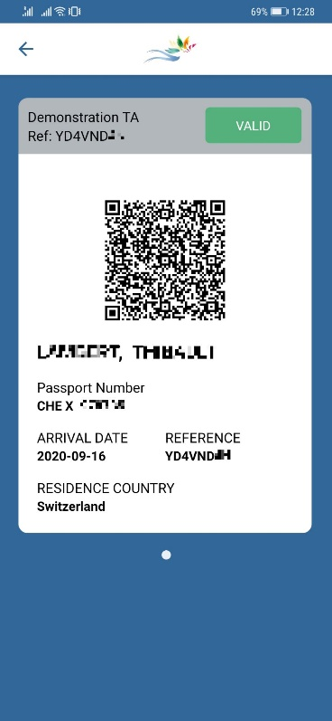
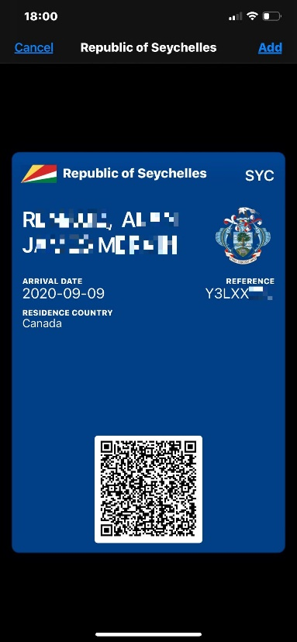
Paper / PDF version: Mobile app version: Apple Passbook :
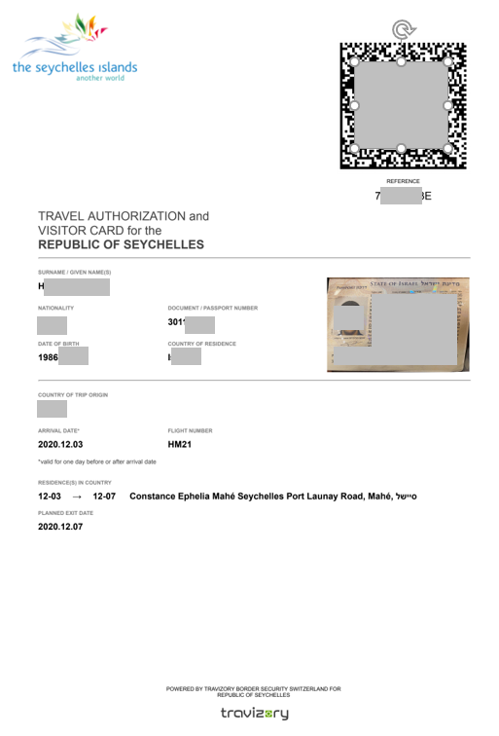

How to verify the authenticity of the Travel Authorization?
If you have doubts about the authorization presented, there are two ways for the check-in staff or boarding staff to verify the authenticity and validity of a Travel Authorization:
- Via the official website https://seychelles.govtas.com
  - Click on the button “Check Authorization Validity” or go directly to https://seychelles.govtas.com/status-check
  - Enter the Travel Authorization Number (Reference) OR enter the passport number and the nationality of the issued passport.
- Via the mobile application T-Validator App by Travizory Border Security SA.
  - Download the application to your Android or iOS device. applications are present
      - iOS: https://apps.apple.com/us/app/id1527560332
      - Android: https://play.google.com/store/apps/details?id=com.travizory.validator.ta

  - Click on the button “Scan Travel Authorization Barcode”
The system validates the barcode of the Travel Authorization and confirms the identity of the approved traveler. Make sure to check the conformity of the data with the presented passport.

What to do if THE TA was not validated OR THE SCAN HAS FAILED?
A non-valid barcode may indicate a forged document and/or a technical issue. In this case, double check on the web platform at https://seychelles.govtas.com/status-check. If the application is still not validated there, please contact support@travizory.com or our chatbot: https://tawk.to/seychelles

