SUBJECT MATTER
1.1. This is an Information Note to update the requirements assigned to the Ministry of Health contained in the Interministerial Ordinance no.
666, of January 20, 2022, which provides for exceptional and temporary measures for entry into the country, under the terms of Law No.
February 2020, regarding disclosure on countries with low vaccination coverage.
2. ANALYSIS
2.1. Preliminarily, it is noted that, in view of the determinations of the Federal Supreme Court in the Claim for Noncompliance with Precept
Fundamental 913 - Distrito Federal, which imposes on the authorities the duty to demand the presentation of proof of vaccination against Covid-19 from
Brazilians and foreigners who enter the country, as well as the Technical Notes nº 112 and 113/2021 of ANVISA and the Opinion of the Executory Force of the
Attorney General of the Union nº 00149/2021/SGCT/AGU, the Chief Ministers of the Civil House of the Presidency of the Republic, Justice and Public Security,
Health and Infrastructure published Interministerial Ordinance No. 663, of December 20, 2021, revoked by Interministerial Ordinance No. 666, of 20
January 2022, providing for exceptional and temporary measures for entry into the country.
2.2. In the aforementioned Interministerial Ordinance No. 666, of January 20, 2022, article 4, item IV, relating to air transport, establishes that:
“CHAPTER II
AIR TRANSPORT
(...)
Art. 4. The presentation of proof of vaccination will be waived for travelers:
(...)
IV - from countries with low vaccination coverage disclosed by the Ministry of Health and published on the ministry's website; and
(...)."
2.3. It should be noted that, under the terms of Decree No. 10.697/2021, the Extraordinary Secretariat to Combat Covid-19 (SECOVID/MS) has the
assignment of "coordination of the measures to be carried out during the public health emergency of national importance arising from the coronavirus
(covid 19)" and the proposition of "national guidelines and actions to implement health policies to face the covid-19 pandemic"
19", being responsible for the execution of these attributions "in articulation with the other secretariats, within the scope of their competences", according to the understanding
of CONJUR, through Order No. 02676/2021/CONJUR[1]MS/CGU/AGU (0021705334) contained in SEI 25000.098221/2021-73.
2.4. That said, with regard to the waiver of presenting proof of vaccination for travelers from countries with low
vaccination coverage, pursuant to art. 4, item IV, of Ordinance No. 666/2021, for the purpose of updating, we inform you that for the definition of countries with low
vaccination coverage, the rate of the immunized population was used as a criterion, regardless of the vaccine for covid-19 used, according to which countries with
less than 10% of the immunized population were listed.
2.5. In this sense, travelers from countries with low
vaccination coverage, regardless of having passed through another country, whose proof of vaccination is required, before entering the
Brazil by air.
2.6. Considering this criterion, we used as a reference the list available at hƩps://www.cdc.gov/quaranƟne/order-safetravel/technical-instrucƟons.html#anchor_1635183089047:

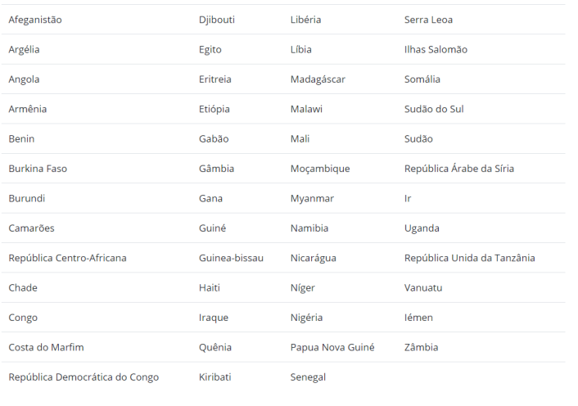

It is also important to clarify that they are considered eligible based on their age for vaccination in Brazil, under the terms of the National Health Plan.
Operationalization of Vaccination against Covid-19 - PNO (available at hƩps://www.gov.br/saude/pt-br/coronavirus/publicacoes-tecnicas/guias-eplanos/plano-nacional-de-operationalizacao-da-vacinacao -contra-covid-19.pdf/), the population over 5 years old, and for the 5-year age group
of age, the only immunizing agent that has been used so far authorized by ANVISA is Comirnaty and for the age group from 6 to 17 years, according to the
authorization from ANVISA, Comirnaty and Coronavac immunizing agents can be used.
2.8. Thus, for the purpose of complying with the requirements for entry into the country, contained in Interministerial Ordinance No. 666, under the terms of
Technical Note 2/2022-SECOVID/GAB/SECOVID/MS (available at hƩps://www.gov.br/saude/pt-br/coronavirus/vacinas/plano-nacional-deoperacionalizacao-da-vacina-contra-a- covid-19/notas-tecnicas/2022/nota-tecnica-02-2022-vacinacao-de-5-11-anos.pdf/view), it should be noted that,
Currently, at least 39 countries in Europe and 14 in Latin America have already authorized or started vaccination against COVID-19 in children under 12
years old. However, it is important to remember that, given the inequality in access to vaccines, the decision to vaccinate children and adolescents must consider the context
and the epidemiological situation of the country at the level of other countries as well: the burden of the disease, the availability of immunizations and local strategies, in order to
prioritize the highest risk subgroups.
2.9. In this sense, Brazilians and residents of the following countries who have already started the children vaccination:

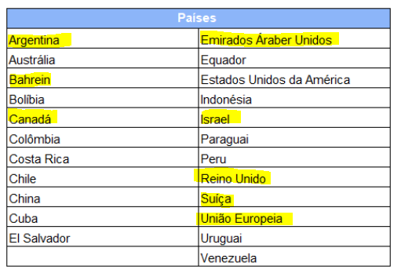

More on It is also important to clarify that they are considered eligible due to their age for vaccination in Brazil, under the terms of the National Plan for the Operationalization of Vaccination Against Covid-19 - PNO (available at hƩps://www.gov.br/ saude/pt-br/coronavirus/publicacoes-tecnicas/guias-eplanos/plano-nacional-de-operationalizacao-da-vacinacao-contra-covid-19.pdf/), the population over 5 years old, and for the age group from 5 years of age, the only immunizing agent that has been used so far authorized by ANVISA is Comirnaty and for the age group from 6 to 17 years, according to ANVISA's authorization, the immunizing agents Comirnaty and Coronavac can be used . 2.8. Thus, for the purpose of complying with the requirements for entry into the country, contained in Interministerial Ordinance No. 666, under the terms of Technical Note 2/2022-SECOVID/GAB/SECOVID/MS (available at hƩps://www.gov.br/saude /en-us/coronavirus/vaccines/national-plan-deoperationalization-da-vaccine-against-covid-19/technical-notes/2022/technical-note-02-2022-vaccination-of-5-11-years .pdf/view), it should be noted that, currently, at least 39 countries in Europe and 14 in Latin America have already authorized or started vaccination against COVID-19 in children under 12 years of age. However, it is important to remember that, given the inequality in access to vaccines, the decision to vaccinate children and adolescents must consider the context and epidemiological situation of the country at the level of other countries as well: the burden of the disease, the availability of immunizations and strategies locations, in order to prioritize the highest risk subgroups. 2.9. In this sense, Brazilians and residents of the following countries who have already started vaccinating children are considered eligible based on their age:
Coronavirus (COVID‑19)
Get the latest information

Therefore, considering the above, they are eligible to present proof of vaccination according to age, as
provided for in Interministerial Ordinance No. 666 of January 20, 2022, travelers over 18 years of age and:
a) Brazilians and foreigners residing in the country aged over 5 years, except for those returning on a trip
started at least thirty days ago;
b) Foreigners aged over 5 years from the countries listed in item 2.9;
c) In the case of resident and non-resident Brazilians and foreigners, over 5 years of age and under 18 years of age traveling
accompanied by a responsible person who does not present proof of vaccination, they must carry out quarantine according to
established in Art. 5 of the aforementioned Interministerial Ordinance No. 666/2022.
3. CONCLUSION
3.1. Thus, considering that information regarding the eligible population is already available on the official website of the Ministry of
Saúde, through the National Plan for the Operationalization of Vaccination against Covid-19, the file is forwarded for the dissemination of information
updated information on countries with low vaccination coverage, as required by Interministerial Ordinance No. 666, of January 20, 2022, as well as
of countries where vaccination of children and adolescents is already underway.
3.2. Finally, considering that the epidemiological and vaccine coverage scenario is dynamic, new Information Notes can be elaborated to
as new data emerge.
3.3. The Extraordinary Secretariat for Combating Covid-19 remains available to provide any additional clarifications that may be required.
make necessary.
Regards,
DANILO DE SOUZA VASCONCELOS
Program Director of the Extraordinary Secretariat to Combat Covid-19
Accordingly,
ROSANA MILK
Extraordinary Secretary to Combat Covid-19

